ALPHA UNIVERSITY BORAMA

Faculty of Computer Science Diploma program

Course: Database Management System

**Assignment 2:**

Relational Databases





Submitted by: Sacad Mukhtaar awmouse Student ID: DIP 25/661

Date: May 12, 2025



Question 1

1. **Student and Student ID Card**
   * **Explanation: Each student in a school or university is assigned one unique Student ID card, and each card belongs to only one student.**
   * **Example:**
     + **Student: Emily Roberts**
     + **Student ID Card: STU202410001**
   * **Why is this 1:1?**
     + **A student has only one ID card.** **An ID card belongs to only one student.** **Answered 1:1**

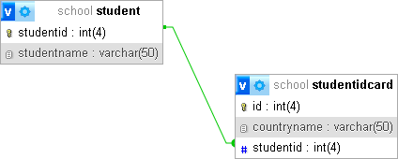

**Answered join 1:1**

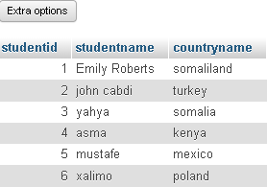

1. **Parent and Children**
   * **Explanation: A parent can have multiple children, but each child has only one biological mother and one biological father.**
   * **Example:**
     + **Parent: Mrs. Johnson**
     + **Children: Emma, Olivia, Liam**
   * **Why is this 1:M?**
     + **One parent → Multiple children.** **Each child → Only one biological mother** **Answered 1:M**

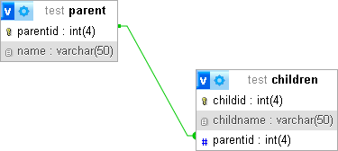

**Answered join 1:M**

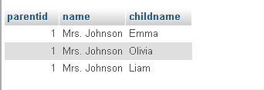

1. **Teachers and Subjects**
   * **Explanation: A teacher can teach multiple subjects, and a subject can be taught by multiple teachers.**
   * **Example:**
     + **Teachers: Mr. Smith, Ms. Johnson, Dr. Lee**
     + **Subjects: Biology, Chemistry, Physics**
   * **Why is this M:M?**
     + **Mr. Smith can teach Biology and Chemistry.**
     + **Ms. Johnson can teach Physics and Chemistry.**
     + **The Chemistry subject can be taught by both Mr. Smith and Ms. Johnson.**
     + **The Biology subject can be taught by Mr. Smith and Dr. Lee.** **Answered M:M**

